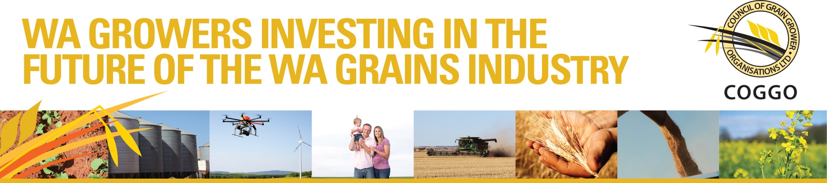
APPLICATION FORM

PIPER GRAINS INNOVATION AWARD
RECOGNISING INNOVATION FOR THE WA GRAINS INDUSTRY

1 Contact Information
Please provide the title of the innovation proposal, name of the proponent (individual, partnership, company, organisation) and contact details on this page.

Title of the Innovation Proposal

Name of Proponent

ACN/Legal Name or ABN

Mailing Address

Administrative Contact

Position

Telephone

Fax

Email
COGGO Use Only
Proposal Number
Date Received
Evaluation Criteria Addressed

2 Outline
This section includes a description of the innovation and the stage of development.

Describe the innovation

What is innovative about your idea?
To what extent is your idea new or different? Has this been done before? What stage of development is it at?

Planned Products or services | Describe the product or service that will be delivered (such as an improved seeder boot, a new computer application, a new innovative consulting service.)

Primary product or service

Other products or services

3 Benefit
Outline the benefits that would result from adoption of your innovation
What will be the improvement in individual business performance for those who adopt your innovation?
What will be the overall benefit to the WA grain industry?

4 Value proposition
Outline your value proposition
A value proposition is a clear statement that:
•explains how your product solves customers’ problems or improves their situation
•delivers specific benefits
•tells the customer why they should buy from you and not from the competition
Why would the intended customer want to adopt the technology / innovation?
Why would they spend money to buy the service, product or process?

5. Market Opportunity
Describe the market opportunity for your innovation.
The size of the target market. Provide an indication of the likely route to market. Are barriers to adoption addressed? Are there any significant regulatory or market factors that would need to be overcome? Can you confirm you have ownership or beneficial use of any intellectual property required for the project? What are the barriers to entry, if any, for competitors? Are there any benefits of the innovation that may see a larger market for the product or service beyond the Western Australian Grains Industry?

5. Project plan
Describe your plan for developing the innovation.
What will be your goals. What are the steps you will take over the next 12 months to develop you innovation? What are the significant achievements? What is the overall financing plan for development of your innovation?

6. Management & Resources
This section describes the people and the major resources to be devoted to the project.
Personnel | List the personnel to be involved. Describe in a sentence their role and their applicable experience and track record in delivering on similar projects. Also provide an estimate of the percentage of their working time that will be devoted to this project
Name | Role | % time allotted

7. Certification
By signing this application form below the Applicant confirms and agrees to the following:
- Certifies that all information contained in, and forming part of, this application is accurate and in good faith as at the date given and that any subsequent changes in the information give will be notified promptly.
- Confirms that they have read and accept the Terms and Conditions of Entry outlined in part B of this application form.
- Confirms they are an Australian citizen or have permanent resident status.
- Confirms that the innovation idea or product submitted for consideration for the Piper Prize is owned by the applicant and all existing Intellectual Property protection identified by the applicant must be in the name of the applicant.
Name
Signature
Date

Please complete this Form and email to coggo@giwa.org.au

Applications must be submitted and received by 5pm AWST Friday 20 May 2016

Terms and Conditions of Entry
Eligibility Criteria
1. Applicants must be Australian citizens or permanent residents and may be an individual, partnership or a company with a registered Australian Business Number (ABN) or Australian Company Number (ACN).
2. The applicant must be able to demonstrate ownership or beneficial use of any intellectual property required for the project.
Terms and Conditions
1. To apply for the award entry forms must be submitted online by 5pm AWST Friday 20th May 2016
2. Submitted material will not be returned. Hard-copy applications will not be considered.
3. COGGO and its agents accept no responsibility for lost, late, incomplete, illegible, or misdirected applications.
4. COGGO acknowledges that the entry is confidential information and that the intellectual property in the entry belongs to the eligible applicant. COGGO undertakes to ensure that only the COGGO Board, the judging panel and its project managers will have access to the application.
5. It is a condition of entry that personal information provided to COGGO in the entry form can be used by COGGO only in connection with the Piper Award for Innovation in the Grains Industry.
6. Finalists will be asked to provide information suitable for promotional purposes.
7. The Applicant indemnifies COGGO and its agents against any liability which may be incurred through the Applicants participation in and application of the Piper Award for Grains Innovation in the Grains Industry.
8. Prior to applying for the Piper Award for Grains Innovation in the Grains Industry Applicants should seek financial advice in relation to any personal financial impacts such as any tax payable on the award. .
9. The deliberations of the judging panel remain confidential.
10. The COGGO Board’s decision will be final and no correspondence will be entered into.
11. The COGGO Board, in its sole discretion, reserves the right not to award the award (including in circumstances where insufficient Applications are received or Applications are judged to be insufficiently meritorious).
Award Conditions
Successful Piper Award Applicants will be expected to have an early discussion with a commercialisation mentor to assist in identifying key elements to be address with their specific innovation opportunity; and a second discussion during the subsequent twelve months for a follow-up consultation to address any emerging issues. COGGO will provide successful Piper Award Applicants with initial access to accredited commercialisation mentors free of charge.
The award will comprise an initial grant of $15,000 and, subject to acceptance by COGGO of a brief progress report after 6 months outlining the steps taken and progress made, a second payment of $10,000. A brief final report will be required outlining the progress made and the goals achieved.
Selection Process
A selection panel comprising members with relevant industry and commercial experience will assess the written applications.
The application form has been structured around the following selection criteria.
1. Benefits
If this product or service is fully commercialised what will be the improvement in individual business performance for those who adopt the innovation? What will be the overall benefit to the WA grain industry?
2. Value proposition
What is the value proposition. Why would the intended customer want to adopt the technology / innovation? Why would they spend money to buy the service, product or process?
3. Market Opportunity
How clearly defined is the market for the innovation?
4. Project plan
Is there a sound plan of activities to move the project forward?
5. Management Capability
Does the applicant demonstrate an appropriate level of expertise or access to expertise.

